HUNTINGDON CONSTITUENCY CONSERVATIVE ASSOCIATION

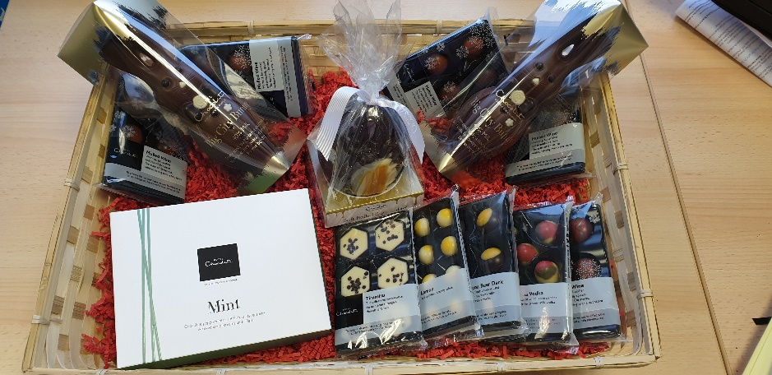
AGM EASTER RAFFLE
Tickets £5.00 per strip – Draw ends 22 March
If you would like to enter our raffle and win a basket of goodies that will keep you going until Easter, please complete the below and return to HCCA via post to Centenary House, St Mary's Street, Huntingdon PE29 3PE.
Alternatively please contact the HCCA office on (01480) 453 062/ admin@huntscca.co.uk.

Name(s)…………………………………………………………………………………..

I/we require …….. raffle ticket(s) and enclose a cheque made payable to HCCA for £…………..

For BACS payment – Sort Code: 20 43 63 Account No: 70500011
(Please include your surname as a reference and ensure this form is returned to HCCA to ensure ).
Promoted by Adam Roberts on behalf of HCCA, Centenary House, St Mary's Street, Huntingdon PE29 3PE

